# Cours UdeMy : ANGULAR and ASP.NET Core REST API - Real World Application

https://mern.udemy.com/course/real-world-app-angular-aspnet-core-web-api-and-sql/learn/lecture/38606284#overview

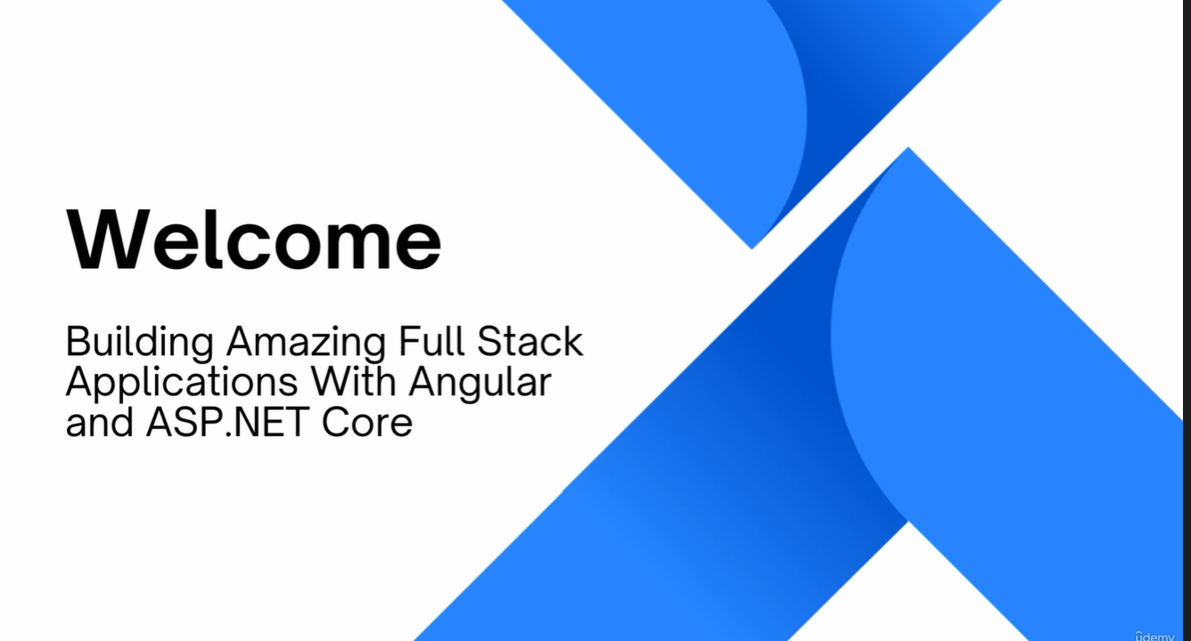

Create Full Stack Web Applications with Angular, ASP.NET Core Web API, Entity Framework Core, C# REST API, JWT Token





